**Desktop publishing**

1 What is desktop publishing?

**A In pairs, discuss these questions.**

1.What kind of documents can be produced with a desktop publishing system?

Books,magazines, leaflets,posters and business cards.

2.Page layout software is the key component of a desktop publishing system. Which file types can be imported into a page layout program?

Text, charts and graphs, illustrations and photographs.

**B Read the text and check your answers to A**

What is desktop publishing?

Desktop publishing (DTP) refers to the use of computers to design and publish books, brochures, newsletters, magazines and other printed pieces. DTP is really a combination of several different processes including word processing, graphic design, information design, output and pre-press technologies, and sometimes image manipulation.

DTP centres around a page layout program. Typically, a layout program is used to import texts created in word processing programs; charts and graphs from spreadsheet programs; drawings and illustrations created in CAD, drawing or paint programs; and photographs. The program is then used to combine and arrange them all on a page. It is this ability to manipulate so many different items and control how they are used that makes layout software so popular and useful. However, modern word processors also have publishing capabilities, meaning the line separating such programs from DTP software is becoming less clear. In general, though, powerful new publishing systems use high-quality scalable fonts and give you control over typographic features such as kerning (adjusting the spaces between letters to achieve even, consistent spacing). Another key feature of DTP software is text flow - the ability to put text around graphic objects in a variety of ways.

Once composed, DTP documents are printed on a laser printer or on a high-resolution imagesetter (see Unit 8). For transfer to a commercial printer, the documents are generally saved in their native page layout format (such as Adobe InDesign or QuarkXPress) or as PDF files. PDF stands for Portable Document Format and allows people to view, search and print documents exactly as the publisher intended - you don't need to have the software and fonts used to create it. PDF files can be published and distributed anywhere: in print, attached to email, posted on websites, or on DVD. To open a PDF file, only the Adobe Acrobat Reader (a free download) is required.

In modern commercial printing, DTP files are output directly to the printing plates without using film as an intermediate step. This new technology is known as Computer-To-Plate (CTP) or direct to plate, and the machine that generates plates for a printing press is called a platesetter. CTP machines are expensive, so most people take their files to a service bureau, a company that specializes in printing other people's files. Service bureaux offer a full range of scanning and printing solutions.

**C Read the text again and aswer these questions.**

1 What type of software is used for the creation of DTP documents?

A page-layout program (also called a desktop publishing program or DTP program)

2 What are three differences between DTP software and word processors?

DTP software is different from a word processor in that it uses high-quality scalable fonts and gives you control over typographic features such as kerning. Another difference is the text flow feature.

3 What is a PDF and what can it do?

PDF means Portable Document Format, a standard format developed by Adobe which allows people to view, search and print documents exactly as the publisher intended

4 Which program do you need to view PDF document?

Adobe Acrobat Reader

5 Why do people send their DTP files to service bureaux?

Because CTP machines are expensive, and service bureaux offer services such as scanning and printing.

**E In pairs, discuss the question What is desktop publishing? in as much detail as you can. Then look back at the text on page 105 to see how much you remembered**.

Desktop publishing (DTP) refers to the use of computers to design and publish books, brochures, newsletters, magazines and other printed pieces. DTP is really a combination of several different processes including word processing, graphic design, information design, output and pre-press technologies, and sometimes image manipulation.

2 Language work: order of adjetives

**A Look at the HELP box and the make phrases using the words in the correct order.**

Example: computer programmer / young / clercer

a clever, young computer programmer

1 software / desktop publishing / user-frindly

user-friendly desktop publishing software

2 hardware company / reliable / young

a reliable, young hardware company

3 German / industry / graphic design

the German graphic design industry

4 word processing / applications / modern

modern word processing applications

5 Sony / new / music player / portable

a new Sony portable music player

HELP box

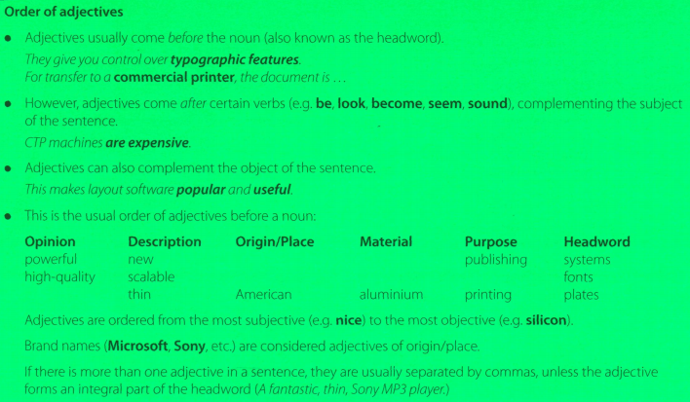

**B Translate these sentences into your own language. How does the use of adjetives differ from English? Think about order and wheter the form of the adjetive changes or not.**

1 DTP refers to the use of personal computers to produce hight-quality printed documents.

DTP se refiere al uso de computadoras personales para producir documentos impresos de alta calidad.

2 A page layout applications is user to import text form word processing programs and pictures from painting and drawing programs

Una aplicación de diseño de página es un usuario para importar programas de procesamiento de texto en forma de texto e imágenes desde programas de pintura y dibujo.

3 In modern commercial printing, DTP files are output directly to the printing plates.

En la impresión comercial moderna, los archivos DTP se envían directamente a las planchas de impresión.

3 Steps in a DTP publication

**A Look at this extract form an online tutorial for DTP publishing. Put the steps in the creation of a DTP document (a-f) into the correct order.**

1a 2c 3e 4d 5f 6b

a First, The DTP designer decides the basic form of the document (the type of document, general design, colour, fonts, images required,etc)

c To create the DTP document, the designer begins by selecting a template ot by specifying by settings of a new document (the page size, margins, columns, paragraph styles, master pages, etc.)

e The next step iss to type the text directly or to import it from a word processing program like Word or WordPerfect.

d When the text has been edited, the designer imports the pictures and uses precises tools to position, scale, crop and rotate all the items.

f Once the file composed an saved, the designer has to prepare it for printing, which involves verifying the colour specification, creating a Postscript or PDF file, exporting the file in HTML format for the Wec, checking proofs,etc.

b The last step is to take the files to a services bareau, which will print the publication.

**C Label the features of this page designer with Adobe in Design (1-6) with words from the box.**

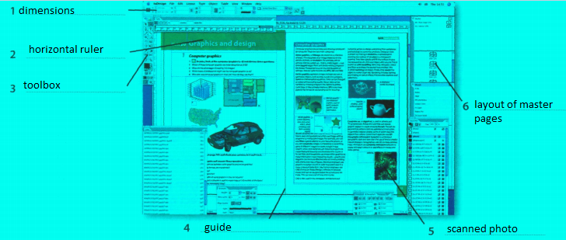

4 Writing a letter

**A Although most written communication these days is carried out by email, letters are still appropriate for more formal correspondence. Look at this letter. What is the writer asking for?**

The whiter is asking for information about the kind of DTP software that the newspaper uses and ways to find out how long the paper’s online edition has been running for

**B Match the parts of the letter (a-h) with the descriptions (1-8)**

1 b For example, 28th March 2008, or 28 March 2008 or 28/03/2008

2 a This is usually in the top right corner of the letter, but can to in the centre if its a printed letterhead.

3 e State the reason for writing: I am / We are writing to / We are currently ...

4 c This should be included on the left hand side of the page, before the greeting.

5 d Start with Dear Sir/Madam or Dear Mr/Mrs/Ms ... Use Ms if you are not sure if the recipient is married or not, It is often best to use Ms, as Mrs can cause offence.

6 f Make any requests or ask any questions you need to We would be grateful if you could ..., Could you also ...

7 g Request further contact, if necessary: We / I look forward to hearing from you. / Please contact us by...

8 h If you have started the letter with the person's name (for example, Dear Mr Robinson), I Iwn end with Yours sincerely. If you do not know the name of the recipient, end with Yours faithfully.

5 E-publishing versus paper publishing

**A Look at this web extract about e-publishing.What examples of e-publishing you find in the text?**

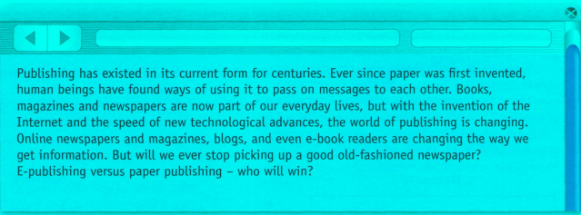

Online newspapers and magazines,blogs, e-books

INSTRUCTIONS FOR ACTIVITIES:  
  
Page 105, ex. 1B, C.  
  
Page 106, ex. 1E, 2A, 2B, 3A.  
  
Page 107, ex. 3C, 4A.  
  
Page 108, ex. 4B, 5A.